Prospect Tracker (v1) — Local-First CRUD System
Audience | Technical reviewers
Scope | System design documentation
Prepared by | Jhondel Mellomida
Last updated | 22/9/2026

1. Overview

1.1 Problem statement (why build vs. spreadsheet)
This tracking system is meant to track client acquisition and its progress, and whether it is worth continuing or not. It is meant to simplify the process and improve the setup for that task.
Rather than using a spreadsheet for tracking, it was decided to build a system to practice coding from scratch, with AI as a guide only and not as a code generator. It is a learning approach, which is why we are building it. Another advantage is the flexibility to shape it around what we want to achieve.

1.2 Goals / Non-goals
Goals
- Serve as a learning exercise for cache-aside invalidation patterns, not just a CRUD app.
Non-goals
- Fine-grained/partial cache invalidation (v1 clears the whole cache on any write).
- Distributed caching (Redis deferred to v2).

2. Requirements

2.1 Functional requirements
ID | Requirement | Priority
FR-1.1 | User can create an application record with company, contact (email/number), date created, last date contacted, technical audit (free text), source, and status. Company and status are required. | Must
FR-1.2 | User can edit an existing application record. | Must
FR-1.3 | User can delete an existing application record. | Must
FR-1.4 | User can see an individual application record. | Must
FR-1.5 | User can page through records. | Must
FR-2.1 | User can add notes to an application record, such as a client response. Notes are auto-timestamped. | Must
FR-2.2 | User can edit notes on an application record, such as a client response. | Must
FR-2.3 | User can delete notes on an application record, such as a client response. | Must
FR-3.1 | User can filter based on status. | Must
FR-3.2 | User can sort records by last contacted date, ascending or descending. | Must
FR-3.3 | User can search by company and source (case-insensitive, partial match). | Must
FR-4.1 | User can set a follow-up reminder (a date, or an offset like "3 days after last contact"). Records due today or earlier are flagged in the list. | Should
FR-5.1 | User can export records to CSV. | Could
FR-5.2 | User can import records from CSV. | Could
FR-6.1 | Login, accounts, and profile management. | Won't
FR-7.1 | System writes an audit log entry (entity, action, old/new values, timestamp) on every create, update, or delete of a record or note. | Must
FR-8.1 | System passes telemetry data for monitoring and analysis. | Won't

2.2 Non-functional requirements
ID | Category | Requirement
NFR-1 | Performance | List endpoint p95 < 500 ms at up to 1,000 records.
NFR-2 | Performance | Search endpoint p95 < 500 ms upon clicking the search button.
NFR-3 | Data Integrity | Deleting a record cascades to its notes and follow-up schedule; no orphans. Audit logs are excluded and survive deletion.
NFR-4 | Reliability | Schema changes only via Django migrations (makemigrations/migrate); every migration is reversible.
NFR-5 | Auditability | Audit entries are timestamped (UTC) and append-only (no edit or delete endpoint).
NFR-6 | Security | API bound to localhost or a private network; v1 is single user with no auth.
NFR-7 | Maintainability | Backend test coverage ≥ 80% on Django views/viewsets.
NFR-8 | Maintainability | Code passes ruff (PEP 8) in CI; source files ≤ 200 lines unless justified in a comment.
NFR-9 | Performance | GET /records list is cached in-process (dict, TTL 30 s) and invalidated on any write to records or notes. Django's LocMemCache will be used.
NFR-10 | Performance | The list endpoint response time target (NFR-1) applies with and without a cache hit; the cache is an optimization, not a requirement for meeting the target.

3. System Interface Definition
REST was used as the main architectural style for its simplicity, since the project is mostly CRUD and monolithic. GraphQL is an alternative; however, changing the architectural style would mean changing the endpoints.

3.1 API endpoints

Records
Method | Path | Purpose | Satisfies | Success | Errors
POST | /api/v1/records | Add application record | FR-1.1 | 201 | 400
PATCH | /api/v1/records/{record_id} | Edit application record | FR-1.2, FR-4.1 | 200 | 404, 400
DELETE | /api/v1/records/{record_id} | Delete application record | FR-1.3 | 204 | 404
GET | /api/v1/records/{record_id} | Get one application record with its notes | FR-1.4 | 200 | 404
GET | /api/v1/records | List records (filter, sort, search, due) | FR-1.2, FR-3.1, FR-3.2, FR-3.3, FR-4.1 | 200 | 400
GET | /api/v1/records/export | Download all records as CSV | FR-5.1 | 200 | None
POST | /api/v1/records/import | Upload CSV to records | FR-5.2 | 201 | 400

Notes
Method | Path | Purpose | Satisfies | Success | Errors
POST | /api/v1/records/{record_id}/notes | Add a note to a record | FR-2.1 | 201 | 404, 400
PATCH | /api/v1/notes/{note_id} | Edit a note | FR-2.2 | 200 | 404, 400
DELETE | /api/v1/notes/{note_id} | Delete a note | FR-2.3 | 204 | 404

Audit
Method | Path | Purpose | Satisfies | Success | Errors
GET | /api/v1/audit-logs | Read-only audit logs, filterable | FR-7.1 | 200 | 400

GET /api/v1/records: query parameters and response
Query parameters
Parameter | Required | Description
status | Optional | One of the allowed status values.
q | Optional | Case-insensitive partial match on company or source.
sort_by | Optional | Default: last_contacted_date.
order | Optional | asc | desc. Default: desc.
follow_up_due | Optional | true returns only records due today or earlier.
page | Optional | Default: 1.
page_size | Optional | One of 10 | 20 | 50 | 100. Default: 20.
Response body
{
"items": [ ...records... ],
"page": 1,
"page_size": 20,
"total": 137,
"total_pages": 7
}
Errors
400 if page_size is not one of the allowed values, or page < 1.

3.2 Request/response contract notes
Topic | Decision | Why
Versioning | /api/v1 prefix. | Project is still in v1 and to create a standard.
Naming | Plural nouns, snake_case in paths, params, and JSON. | Follows PEP 8 (NFR-8) and DRF / Django conventions.
IDs | Integer, auto-increment. | Single user and easier to set up for v1.
Dates | Date fields (last_contacted_date and follow_up_date) follow YYYY-MM-DD; created_at and updated_at as ISO 8601 UTC with Z. | A date field is not a moment in time, so it shouldn't carry a timezone.
Update semantics | PATCH only. | Users edit one field at a time, and PUT would force sending everything.
Success codes | POST 201 with body, GET 200, PATCH 200 with updated object, DELETE 204 with no body. | One rule per method. PATCH returns the object so the UI doesn't need a second GET.
Error shape | {"detail": "..."} for 404 and 400, and keep Django's default 400 body for validation. | Zero custom code, and the client handles one top-level key.
Error codes | Document only 404 and 400 (import). 405 and 500 are framework or infrastructure concerns, not per-endpoint design. | Every listed code should be something your handler deliberately produces.
Pagination | Page-number based (page, page_size), not cursor-based. Allowed sizes: 10, 20, 50, 100. Response wraps items in an envelope with page, page_size, total, total_pages. | Cursor pagination solves problems you don't have (high write concurrency, huge datasets). Page number is simpler to implement and to page through in a UI with numbered buttons.
Auth / CORS | None (NFR-6). CORS allows only the Next.js origin (e.g., http://localhost:3000). | Stated explicitly so it's a decision, not an omission.
Caching | Server-side, in-process dict, TTL 30 s, full invalidation on any record/note write. No HTTP cache headers (Cache-Control/ETag) in v1. | Keeps cache logic entirely server-side and simple to reason about; avoids conflating two different caching mechanisms.

4. Estimation

4.1 Scale assumptions (even at trivial scale)
Dimension | Assumption | Basis
Users | 1 | Single user v1
Records (total) | ~540 over 6 months | 3/day average (realistic range 1–5/day) × 180 days
Records (total, ceiling) | 1,800 over 6 months | 10/day stretch goal × 180 days
Records (growth rate) | ~3/day (~90/month) steady state | Anchor metric
Notes per record | 3 | Initial, ongoing, and conclusion
Writes per record (lifetime) | ~6 | 1 create + 2 edits + 3 notes
Requests per day | ~38 (~18 writes + ~20 reads) | Derived from records/day × lifetime writes, and estimated session count
Read:write ratio | ~1:1 | Recomputed, not assumed
Peak concurrency | 1 | Single user v1
Data size (rough) | ~972 KB (~0.95 MB) (~97.2 KB + ~291.6 KB + ~583.2 KB) | ~180 bytes per row for records (~540), notes (~540 × 3 = ~1,620), and audit logs (~540 × 6 = ~3,240)

5. Data Model

5.1 Schema
Table records {
record_id integer [pk, not null, increment]
company string [not null]
status status [not null]
company_contact_no string
company_email email
last_date_contacted date
technical_audit string [note: "Free form text for the audit report summary"]
source source [note: "Application where the client data comes from"]
created_at timestamp [not null, default: `now()`]
modified_at timestamp
}

Table notes {
note_id integer [pk, not null, increment]
record_id integer [not null]
content string
created_at timestamp [not null, default: `now()`]
modified_at timestamp
}

Table follow_ups {
follow_up_id integer [pk, not null, increment]
record_id integer [not null, unique]
content string
follow_up_date date
created_at timestamp [not null, default: `now()`]
modified_at timestamp
}

Table audit_logs {
log_id integer [pk, not null, increment]
entity_type string [not null, note: "'record' | 'note' | 'follow_up' — always explicit, no default"]
entity_id integer [not null, note: "No FK on purpose — must survive deletion of the parent entity (NFR-3)"]
action string [not null, note: "'create' | 'update' | 'delete'"]
initiator string [not null, default: "system", note: "Placeholder until v2 auth adds real users"]
content string
created_at timestamp [not null, default: `now()`]
}

Ref: notes.record_id > records.record_id [delete: cascade]
Ref: follow_ups.record_id - records.record_id [delete: cascade]

enum status {
contacted
ongoing
completion
}

enum source {
reddit
discord
facebook
linkedin
others
}
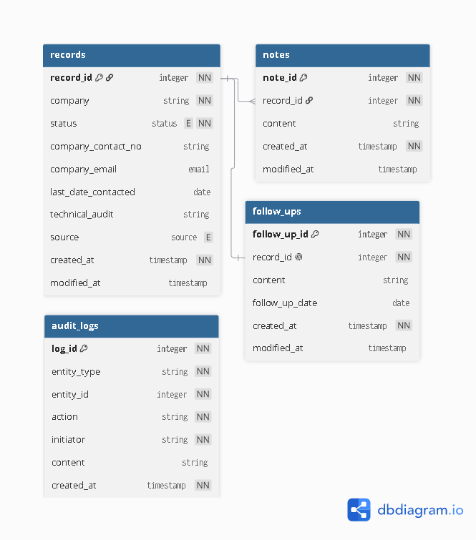

5.2 Decision: fixed follow-up columns vs. separate follow_ups table

ADR-0001: Separate follow_ups table vs. fixed columns on records
Status: Accepted
Context
FR-4.1 describes one follow-up per record, so the relationship is one-to-one. This made fixed columns a legitimate option worth weighing seriously, not a table-by-default choice. The deciding question was whether that one-to-one assumption is likely to hold beyond v1.
Decision
Decided to use follow-ups as a separate table.
Alternatives considered
Option A: Fixed columns on records
- Pros: Simplicity, easy access from records without a join.
- Cons: No extra metadata and not normalized.
Option B: Separate follow_ups table
- Pros: Normalized, cleaner look, proper standard.
- Cons: Extra table and extra complexity for joins.
Rationale
Option A (fixed columns) is the simpler and more appropriate choice for v1's stated requirement of one follow-up per record. However, if a future version needs to support multiple follow-ups per record, Option B avoids a breaking migration: the table already models the one-to-many shape, so relaxing ref: - to ref: > requires no data restructuring. Option B is chosen as a deliberate trade: one extra join today, to avoid a schema rewrite later.
Consequences
This choice adds a join on every GET /records/{id} and an extra table to include in cascade-delete rules, compared to Option A. In exchange, if a future version needs multiple follow-ups per record, the change is a one-line relationship update (ref: - → ref: >) rather than a breaking schema migration. Revisit this decision if a future requirement needs a follow-up history rather than a single reminder per record.

6. High-Level Design

6.1 Architecture diagram
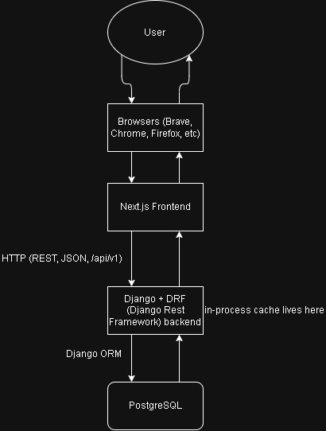
PostgreSQL and the Django backend run together via a single docker-compose.yml (two services, shared network) for local development, for environment isolation and easy teardown/rebuild. The Next.js frontend runs natively (npm run dev); containerization offers no benefit for the frontend dev workflow and can slow hot-reload.

Read (Cache Hit / Miss) Flow
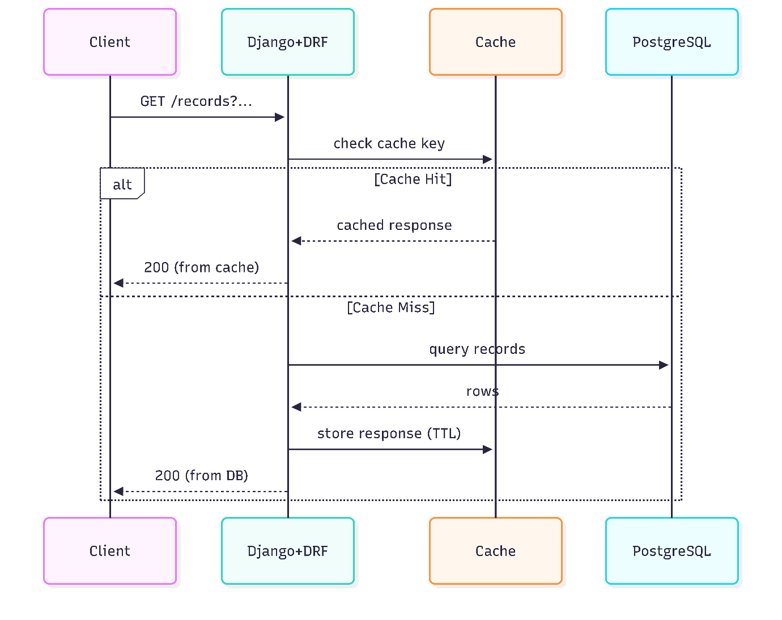

Write (DB Write → Audit Log → Cache Eviction) Flow
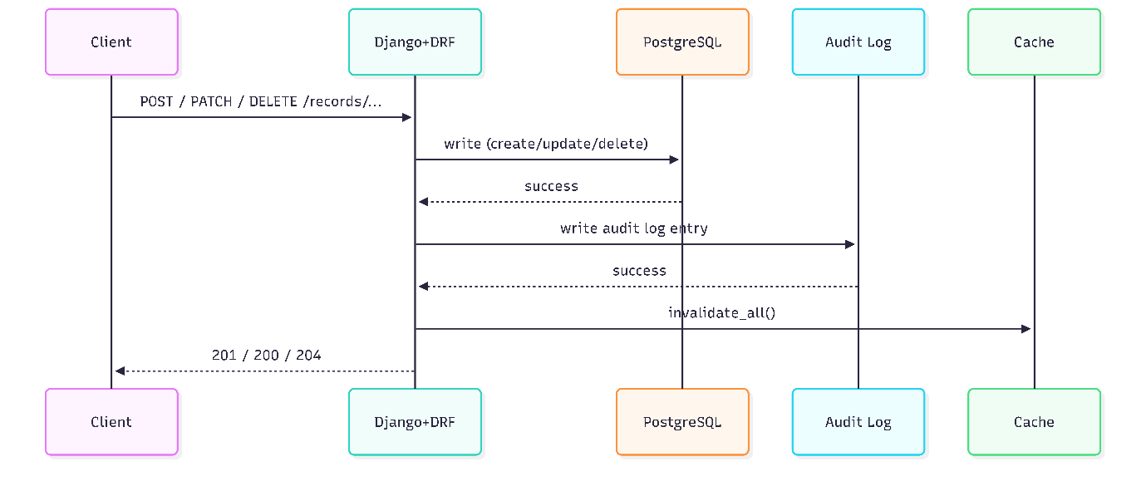
Record writes and audit log inserts are executed within an atomic database transaction to guarantee no audit drift if an error occurs.

6.2 Decision: stack rationale, if any alternative was seriously considered

ADR-0002: PostgreSQL over SQLite / MySQL-MariaDB
Status: Accepted
Context
The options are PostgreSQL, SQLite, and MySQL/MariaDB. These are the options mainly because of developer familiarity and because they are the most common relational databases. A relational database was picked mainly because the project is a simple CRUD app using structured models. NoSQL was not considered, since the data is structured and relational by nature (records, notes, follow_ups, audit_logs with clear relationships).
Decision
PostgreSQL.
Alternatives considered
Option A: SQLite
- Pros: Zero configuration, single file, no separate server process to run or manage. Fully sufficient for this project's data volume (~0.95 MB at 6-month scale, per section 4). Simplest possible local development setup.
- Cons: Not commonly used in production/team environments or listed as a target skill for the roles this project is meant to build experience toward. Weaker support for concurrent writes if the project ever grows past single-user (v2 consideration, not a v1 blocker).
Option B: MySQL / MariaDB
- Pros: Also widely used in industry, well documented, broad hosting support.
- Cons: Historically weaker native support for enum types and case-insensitive text matching compared to Postgres, both used directly in this project's schema (status/source enums, citext-style email handling in section 5). Would require workarounds (e.g., VARCHAR + CHECK constraints) to achieve what Postgres supports natively.
Option C: PostgreSQL
- Pros: Native enum types and citext, both already used in the schema design. Strong standards compliance and widely considered a modern default for new backend projects. Directly relevant to the developer's target roles (e.g., DOST postings).
- Cons: Requires a running database server even in local development (via Docker or a local install), unlike SQLite's zero-setup, file-based approach.
Rationale
PostgreSQL was chosen primarily to align with the project's goal of building experience with a database commonly required in target roles (e.g., DOST postings). This is a deliberate trade: SQLite would technically be sufficient, and arguably simpler, for this project's actual scale (single user, < 1 MB of data per section 4). Postgres is chosen anyway because the skill-building goal outweighs the simplicity SQLite would offer at this scale.
This decision is also supported technically, not just by career goals: the schema (section 5) already uses native enum types (status, source) and case-insensitive email handling, both of which Postgres supports natively and more cleanly than MySQL/MariaDB would.
Consequences
This decision would be revisited if requirements change to include media or large files, in which case Supabase would be used for both storage and database.

ADR-0003: Django + DRF over FastAPI
Status: Accepted
Context
The original plan was built around FastAPI with Pydantic schemas and SQLAlchemy/Alembic for the data layer. This was the first choice mainly because of familiarity and the simplicity of the project. It was then revisited for the same reason as ADR-0002: the developer is building experience with tools commonly required in target roles, and Django is requested more frequently than FastAPI. The decision was made after the API contract and data model had already been designed, and the alternatives were evaluated against the existing design (Alembic vs. Django migrations).
Decision
Django + DRF.
Alternatives considered
Option A: FastAPI (original plan)
- Pros: Native async support, minimal boilerplate for a pure API, automatic OpenAPI/Swagger docs generation, Pydantic validation built directly into route signatures.
- Cons: Less commonly listed as a target skill for the roles this project is meant to build experience toward. No built-in admin interface, ORM, or auth system; those would need to be separately chosen and wired in if the project grows.
Option B: Plain Django (no DRF)
- Pros: One framework to learn instead of two layered together; full visibility into the request/response cycle without a library abstracting it.
- Cons: No built-in request validation, pagination, or structured error formatting, all of which section 3.1/3.2 already assumes (pagination envelope, PATCH semantics, 422-equivalent error responses). Would require hand-building functionality that already exists in a standard library, for no added learning value specific to this project's stated goals.
Option C: Django + DRF
- Pros: Serializers (validation + response shaping) map directly onto the role Pydantic schemas were playing in the original design. Built-in pagination and generic views closely match the contract already designed in section 3. DRF is the de facto standard for building REST APIs in Django, so it's the realistic skill pairing for Django-based roles.
- Cons: Adds a second library's conventions (Serializer, ViewSet, generics classes) on top of Django itself, which is more to learn than Option A or B individually. More setup/boilerplate (settings, app structure, routers) than FastAPI's minimalism, for a project at this scale.
Rationale
Django + DRF was chosen primarily for the same career-relevance reason as PostgreSQL (ADR-0002): it is the stack most consistent with target roles. This is reinforced by a concrete technical fit: the API contract in section 3.1/3.2 (pagination envelope, PATCH-based partial updates, structured validation errors) was already designed in a shape that matches DRF's own built-in defaults, before DRF was chosen. This suggests the contract and the tool are well matched, rather than the tool being forced onto an unrelated design.
Consequences
This choice gives up FastAPI's native async support and lighter footprint, trading them for Django's batteries-included ecosystem (admin panel, auth system, ORM, migrations) and closer alignment with target job postings. It also means learning DRF's conventions in addition to Django's own, which FastAPI + Pydantic would not have required as a second layer. Revisit this decision if a future version needs high-throughput async I/O or very low per-request latency at scale, conditions under which FastAPI's async-native design would offer a real advantage that Django's (largely synchronous, by default) request handling does not.

7. Low-Level Design

7.1 Django models

7.2 DRF Serializers

7.3 Django migrations

7.4 Route handlers

8. Bottlenecks & Future Considerations
CDN and reverse-proxy caching (e.g., Nginx/Varnish in front of Django) is not needed at v1 scale (single user, concurrency = 1, see section 4). Revisit if the app moves to multi-user with geographically distributed traffic, or if static asset volume grows enough that Next.js's own deployment-level CDN (e.g., via Vercel) isn't sufficient on its own.

8.1 What breaks at multi-user scale

8.2 v2 candidates (auth, concurrent writes, data isolation)
If this project moves toward team development or production deployment, revisit containerizing the frontend as part of a full docker-compose stack. Local dev and deployment have different needs, and this decision applies to local dev only.

9. Testing Plan

9.1 What Pytest covers for v1

